Discovery School r-Labs Spring Semester

The Spring Semester 3D Printing Class at Discovery Charter School is off to a great start with 16 students and a fantastic turnout for our first day of labwork. Nine of the students signed up for lab time on Saturday to work with their CAD designs and then print them on the 3D printers at r-Labs.
We have a great mix of students, some like Maher, Travis, Ben and Kazuya are experiences designers and printers coming back for a third or forth time. Others like Kamya are first timers.

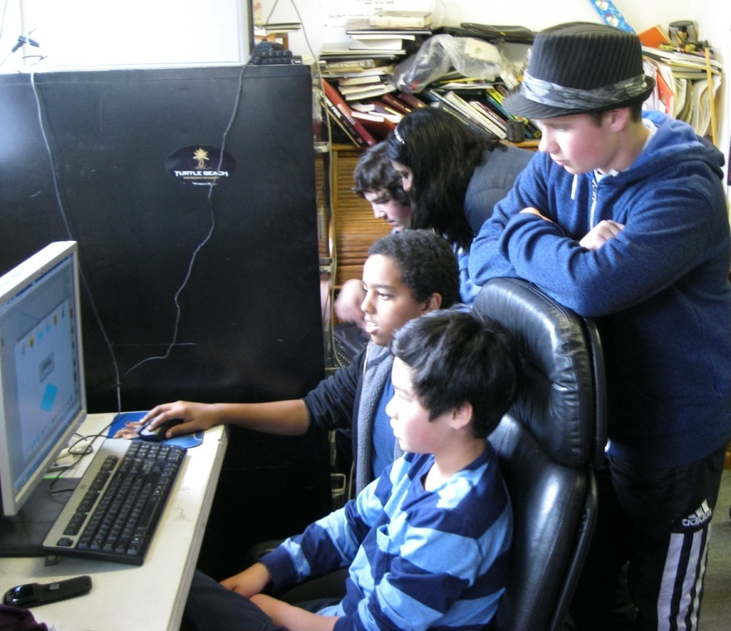
Tim, Travis, Maher, Tamya & Ben hard at work

Discovery School is a public school in San Jose California with a hugely diverse population where we have been able to run a class on 3D Printing and CAD since 2011 thanks to folks like 3D Systems, Autodesk, AMD and other sponsors. The lab is hosted at r-Labs where all the 3D Printers are maintained, workstations provided and endless amounts of chips and bean dip consumed.
Saturday afternoon the students came rushing in with a number of designed ready to be processed in Cubity (or Axon and printed).
Enrique was off to a fast start with a modestly complicated bug that he had designed. A key learning for the students in designing for filament based 3D Printing is to be sure that their item can actually print. Enrique did a great job of ensuring that the design was broken down into individual parts that would print well on the Cube Printer and then be easily assembled.
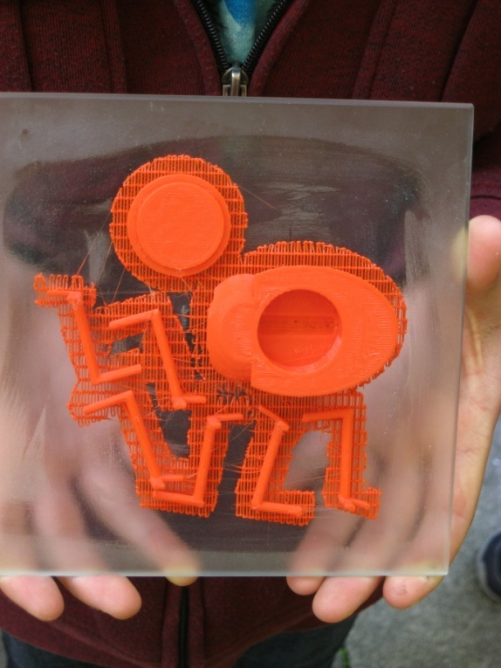
Enrique’s Bug Layout

The layout was excellent and assembly easy. Enrique also did a great job of measuring and designing in the internal channels to hold the LED in the Bug’s mouth, the cavity for the battery and the cap for the battery compartment. Once the rafts were peeled off, assembly was quick and Enrique had a light up bug.
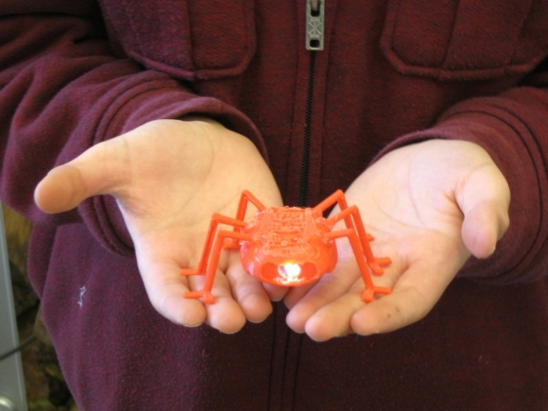
Students who are new to the class, like Kamya, are partnered up with one of the more experienced students in what has mostly become a Self Organized Learning Environment (S.O.L.E). As always first timers to the lab are fascinated by the physical process of printing as they learn the workflow from Idea to Physical Object.
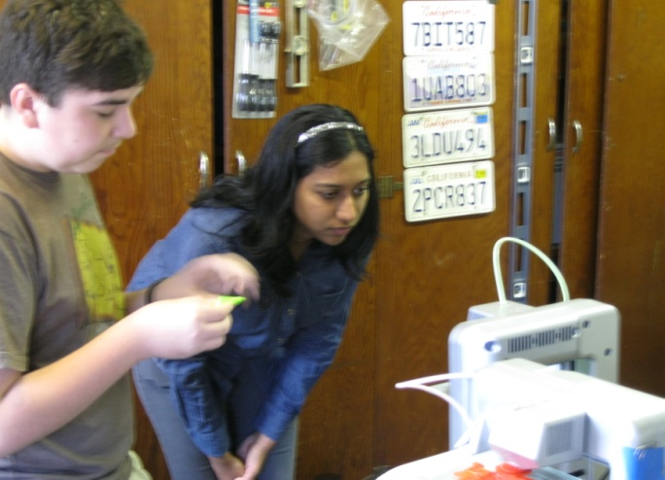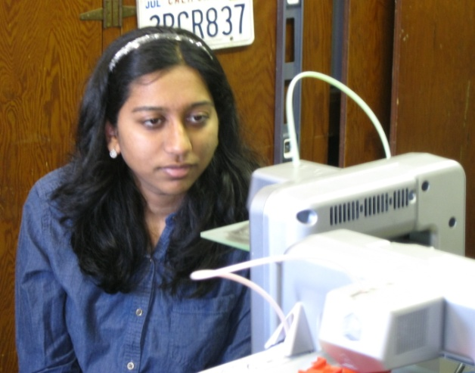
Josh & Kamya with a Cube Printer

The lab does get a little over the top at times. Travis decided that his 13-year-old mustache was inadequate, so he designed and printed his own!
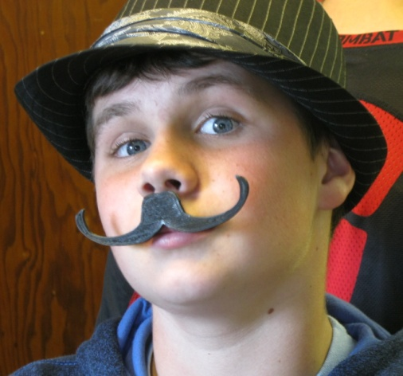
Nice!
Moving forward this semester the students are getting ready for two full days of teaching 3D Printing at the Stanford Splash and sharing our story with about 200,000 of our closest friends at MakerFaire 2014 in San Mateo.
If you want to know more about this “selective” class at Discovery School, drop a note to: MakerDad@rocketmail.com

